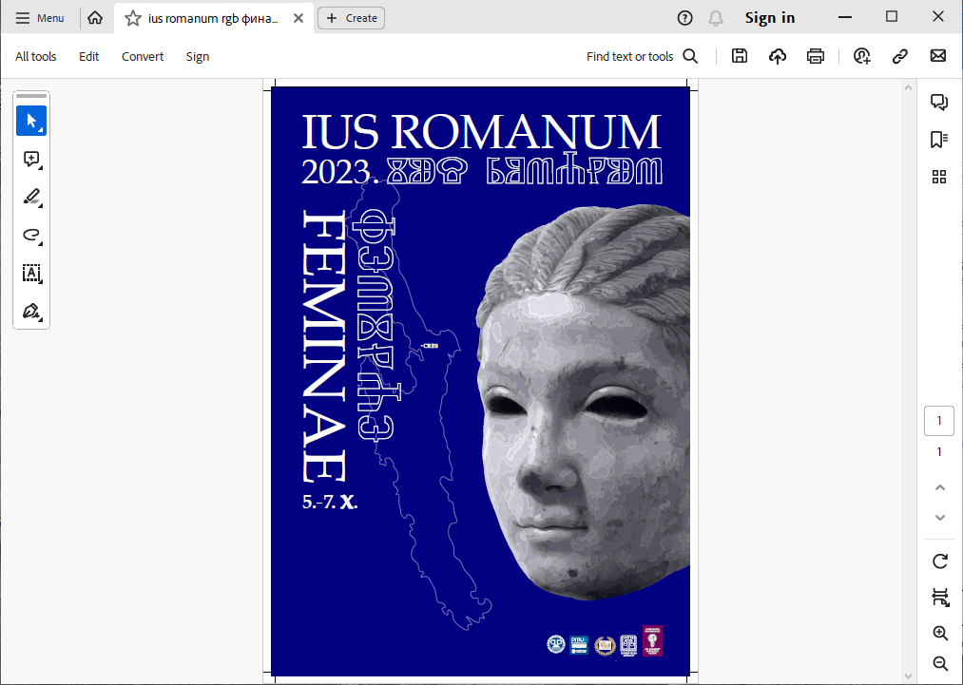

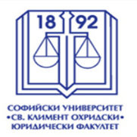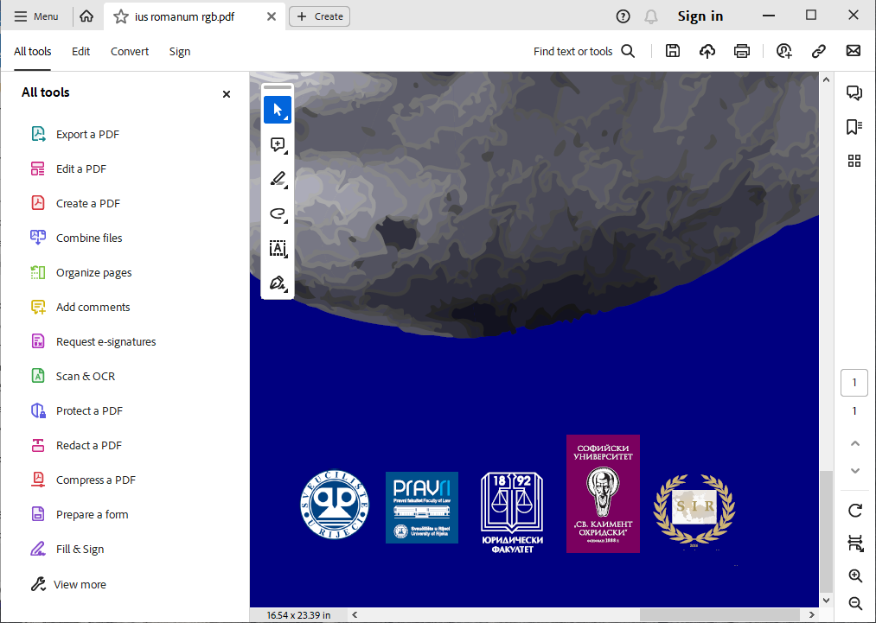

**VIIITH INTERNATIONAL CONFERENCE OF THE BALKAN ASSOCIATION OF ROMAN LAW AND ROMAN LEGAL TRADITION *SOCIETAS PRO IURE ROMANO***

***F E M I N A E***

**(Cres, October 5th – 7th 2023)**

**Conference Program**

**Thursday, October 5th 2023**

- arrival and accommodation of participants in the hotel *Kimen* (Cres, Melin I/16)

19,00 – welcome cocktail

**Friday, October 6th 2023**

9,00 – participant registration (Cres, Palace *Moise*, Zagrad 6)

9,30 – opening of the conference and welcome speeches:

Full Prof. Snježana Prijić Samaržija, Ph.D., Rector of the University of Rijeka,

Full Prof. Dario Đerđa, Ph.D., Dean of the Faculty of Law, University of Rijeka,

Full Prof. Malina Novkirishka Stoyanova, Ph.D., President of *Societas pro iure romano.*

10,00 – plenary presentations (15 minutes each):

Full Prof. Marija Ignjatović, Ph.D., *The Role and Position of Women in Ancient Rome,*

Full Prof. Malina Novkirishka Stoyanova, Ph.D, *Mater Familias,*

Full Prof. Salvatore Puliatti, Ph.D., *Female Image and Protection of Women in Late Antiquity,*

Full Prof. Valerius M. Ciuca, Ph.D.; Full Prof. Mircea-Dan Bob-Bocşan, Ph.D., *A Ship, Named* Feminae*, in the Mediterranean Port Ovidius… Some Ovidian, Legal and Moral, Ideas. Florilegium*

Full Prof. Anamari Petranović, Ph.D., (In)firmitas of Feminae *(The Roman Approach to the Mediaeval Item).*

11,15 – 11,45 – coffee break

11,45 – presentations by sessions (presentations 10 minutes each):

**Session I:**

Full Prof. Emilija Stanković, Ph.D., *Wages for women who embroidered according to Diokletian's Price Edicts,*

Full Prof. Milena Polojac Ph.D., Consortium *and women,*

Assoc. Prof. Valentina Cvetković-Đorđević, Ph.D., *Women’s Legal Capacity – An Overview of the Roman Law and the 1844 Serbian Civil Code Solutions,*

Assoc. Prof. Simeon Groysman, Ph. D., Feminae-peregrinae*, Religious Marriage and Women's Rights: Modern dialogues with Ideas of Ancient Societies,*

Assoc. Prof. Novak Krstić, Ph.D., *Widow’s Usufruct in Roman Law and Contemporary Law,*

Assoc. Prof. Vladimir Vuletić, Ph.D., *Feminae: imbecilitas aut optimus sexus,*

Assoc. Prof. Esin Kranli Bajram, Ph.D., *The Role of Woman in Roman* matrimonium iustum*,*

Assist. Prof. Tihomir Rachev, Ph.D., *Women, Obligations, Liability -* Senatusconsultum Velleianum*,*

Assist. Prof., Mirjana Miškić, PhD, *Women’s Legal Capacity in the Context of* actiones adiecticiae qualitatis.

**Session II:**

Full Prof. Iole Fargnoli, Ph.D., *Imperial Women in the, so Called, Military Anarchy,*

Full Prof. Gian Luca Gregori, Ph.D., *The* iusIII vel IIIIliberorum *in Epigraphic Sources*,

Assoc. Prof. Željko Lazić, Ph.D.; Assist. Prof. Danilo Rončević, Ph.D.; Martin Matijašević, Ph.D., *Torts in Roman Law with Special Emphasis on the Position of Women as the Perpetrator of the Punishable Act,*

Assoc. Prof. Anisoara Babalau, Ph.D., *Wives, Concubines and Daughters of Roman Officials with Financial-fiscal Duties in Epigraphic Sources from Roman Dacia,*

Assist. Prof. Metodi Todorov, Ph.D., Bona materna *According to the Constitutions of Emperor* *Constantine I in the* Codex Theodosianus *(CTh.8.18.1-3),*

Assist. Prof. Milan Milutin, Ph.D., *Dowry and the Responsibility for* mora debitoris *in the Roman Classical Texts,*

Sara Mitić, Ph.D., Teaching Assist., *The Hereditary Status of Women after the Senate Decisions*

Maria Albu, Ph.D., Senior Lecturer, *The Dacian Woman and her Life Until the Roman Conquest of Dacia,*

Linda De Maddalena, Ph.D., Senior Researcher, Feminae *and Guardianship: Overcoming the Archaic Stereotype of* levitas animi*?*

Petrut - George Bran, Ph.D., Lecturer, *The Dowry Action.* *The Woman’s Privilege Over Other Mortgage Creditors,*

Ivan Belaj, Mag. Iur., Senior Lecturer, *The Roman Presumption of* mater semper certa est *and the Protection of Motherhood in Modern Law.*

**Session III:**

Full Prof. Ivana Jaramaz Reskušić, Ph.D., *Prostitution in the Context of Roman Criminal Law,*

Prof. Teodor Sambrian Ph.D., Femina et crimina*: Women as the Subject of the Crime in Roman Criminal Law,*

Full Prof. Darko Dimovski, Ph.D., Ivana Milovanović, Teaching Assist., *Femicide as a Historical Fact and Social Reality,*

Assoc. Prof. Ivan Milotić, Ph.D.; Assoc. Prof. Dunja Milotić, Ph.D., *Roman Sorcery and its Reflections in Medieval Communes on Eastern Adriatic Coast,*

Assist. Prof. Jelena Zovko, Ph.D., *Some Legal Aspects of Women as Victims, Perpetrators and Accusers of a Crime in Roman Law,*

Dr. hab. Piotr Sadowski, Ph.D., *Women and Prison in the Light of the Imperial Constitutions of the Late Roman Empire,*

Monica Ferrari, Ph.D., Postdoctoral Researcher, *Dying for Love: ‘Femicides’ in Roman Egypt in the 4th Century (P. Aktenbuch Pages 3-8),*

Ionela Cuciureanu, Ph.D. Candidate, Assoc. Teaching Asist.; Alexandra Cretu, Student, *The Witches' Trials in Ancient Rome – The Black Swans of Roman Justice.*

**Session IV:**

Full Prof. Nebojša Ranđelović, Ph.D., *Excerpts on Women in the Law of Medieval Serbia,*

Full Prof. Mirjana Akimovska-Polenak, Ph.D.; Full Prof. Vlado Bučkovski, Ph.D., Full Prof. Goce Naumovski, Ph.D., Panče Kjosev, LL.M, *Analysis of Certain Characteristics of Byzantine Rhetoric,*

Full Prof. Željko Bartulović, Ph.D., *Some Questions of the Legal Position of Women in Statutes of Kvarner from the End of 13th until the Middle of the 15th Century,*

Assoc. Prof. Ivona Šego-Marić, Ph.D.; Ivana Marušić, LL.M., Teaching Assist., *Testamentum in Roman Law and Statement of the Last Will of Katarina Vukčić Kosača,*

Assist. Prof. Ines Matić Matešković, Ph.D.; Assist. Prof. Danijela Vrbljanac, Ph.D., *The Marital Property Regime and the Position of Women under Medieval Statutes in Kvarner and Istria: A Glimpse Forward,*

Assist. Prof. Janko Paunović, Ph.D., *The Right of Dowry in the Statute of Kotor,*

Assist. Prof. Aleksandra Szymańska, Ph.D., *Non-dotal Assets of the Wife in Medieval and Early Modern Commentaries on the* Corpus Iuris Civilis,

Assist. Prof. Jelena Kasap, Ph.D.; Assoc. Prof. Višnja Lachner, Ph.D.; Full. Prof. Miro Gardaš, Ph.D., *The Position of Widows in the Late Medieval Statutes of the Kvarner and Dalmatian Regions,*

Lorenzo Lanti, Ph.D. Student, *Between Canones and Leges: the Legal Status of* feminae subitroductae.

**Session V:**

Full Prof. Dževad Drino, Ph.D.; Assoc. Prof. Dejan Matić, Ph.D., Locatio conductio operis *of Bosnian and Serbian Medieval Law,*

Full Prof. Budislav Vukas, *The Role of Provisions on Human Rights Protection in Constructing the Nord Adriatic Identities,*

Full Prof. Zrinka, Erent-Sunko, Ph.D.; Assist. Prof. Miran, Marelja, Ph.D., *The Legal Position of Women in Militarized Societies,*

Assoc. Prof. Berat Aqifi, Ph.D., *The Role of the Cadastre Buildings in Establishing the Ownership of Floors in the Legal System in Kosovo,*

Assoc. Prof. Sanja Gligić, Ph.D., *Greek Women v. Roman Women,*

Assist. Prof. Timčo Mucunski, Ph.D.; Full Prof. Aleksandar Klimovski, Ph.D., *The Function of the* peculium *in Roman Legal, Economic and Social Relation,*

Assist. Prof. Stoyan Ivanov, Ph.D., Iura, feminae, monetae. *The Rights and the Power of Women in Rome Represented in the Imperial Coinage,*

Assist. Prof. Cristina Pop, Ph.D., *Empress Theodora, the New Version of a 6th Century* mater familias,

Artur Tarlapan, Ph.D., Lecturer, *The Right of Inheritance of the Surviving Spouse in the Civil Code of the Republic of Moldova.*

- discussion and completion of all sessions by 14,00

- lunch at the hotel for those who have arranged lunch with hotel **is served until 15,00**

- free afternoon,

20,00 - gala dinner for participants (and companions who paid for gala dinner).

**Saturday, October 7th 2023**

9,00 - 15,00 – free time, possible viewing of Museum in Cres