CRES SUMMER SCHOOL IN LINGUISTIC FIELDWORK AND DOCUMENTATION (CresSSLing)
July 4th to July 8th, 2022, Palace Moise, Cres, Croatia

University of Rijeka, Croatia

Doctoral Program in the History and Dialectology of the Croatian Language
Center for Language Research

 | Sun, 3 July | Mon, July 4 | Tue, July 5 | Wed, July 6 | Thur, July 7 | Fri, July 8
9:30-11 |  | Stolac/Vranić | Stolac/Vranić | Stolac/Vranić | Stolac/Vranić | Stolac/Vranić
11:30-13 |  | Vrzić | Vrzić | Vrzić | Vrzić | Vrzić
 |  | Lunch break | Lunch break | Lunch break | Lunch break | Lunch break
14:30-16 |  | Langston | Langston | Langston | Langston | Langston
16:30-18 |  | Kahl | Kahl | Kahl | Kahl | Kahl
18:15-19 |  |  | Office hours | Student presentations | Office hours | Student presentations
19:30 | Greetings, introductions |  |  |  | Dinner | School closing

Course instructors and courses
- Thede KAHL (University of Jena), Practical aspects of fieldwork and interaction with communities speaking minority/regional/non-territorial languages (IN ENGLISH)
- Keith LANGSTON (University of Georgia), An introduction to Praat and ELAN for field linguists (IN ENGLISH)
- Diana STOLAC (University of Rijeka), Textological research (with an emphasis on historical syntax) (IN CROATIAN)
- Silvana VRANIĆ (University of Rijeka), Fieldwork in dialectology (with a focus on Croatian regional dialects) (IN CROATIAN)
- Zvjezdana VRZIĆ (New York University), Essentials of language documentation (IN ENGLISH)
Organizers: Silvana Vranić and Zvjezdana Vrzić
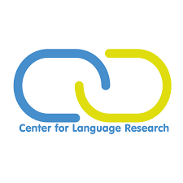
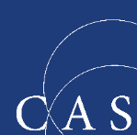
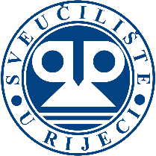
The programs at the Palace Moise are coordinated by the Center for Advanced Studies Southeast Europe of the University of Rijeka.

